UX Case Studies

AmWay (with NEWLY’s design)

KELP (redesign)

PULITO

StratfordBlooms Redesign

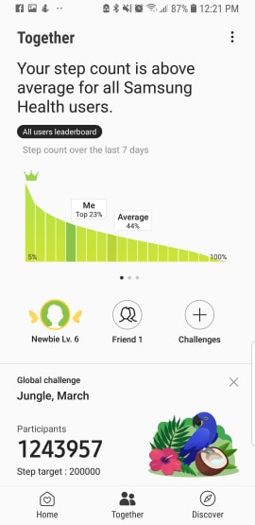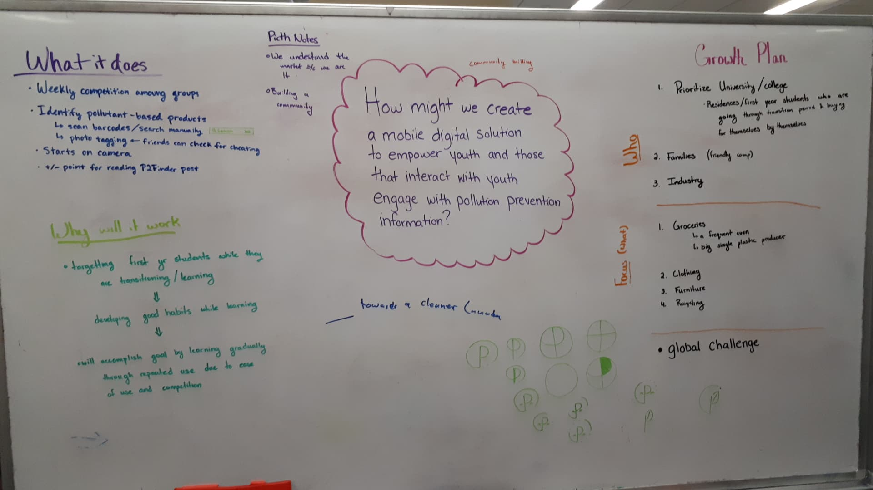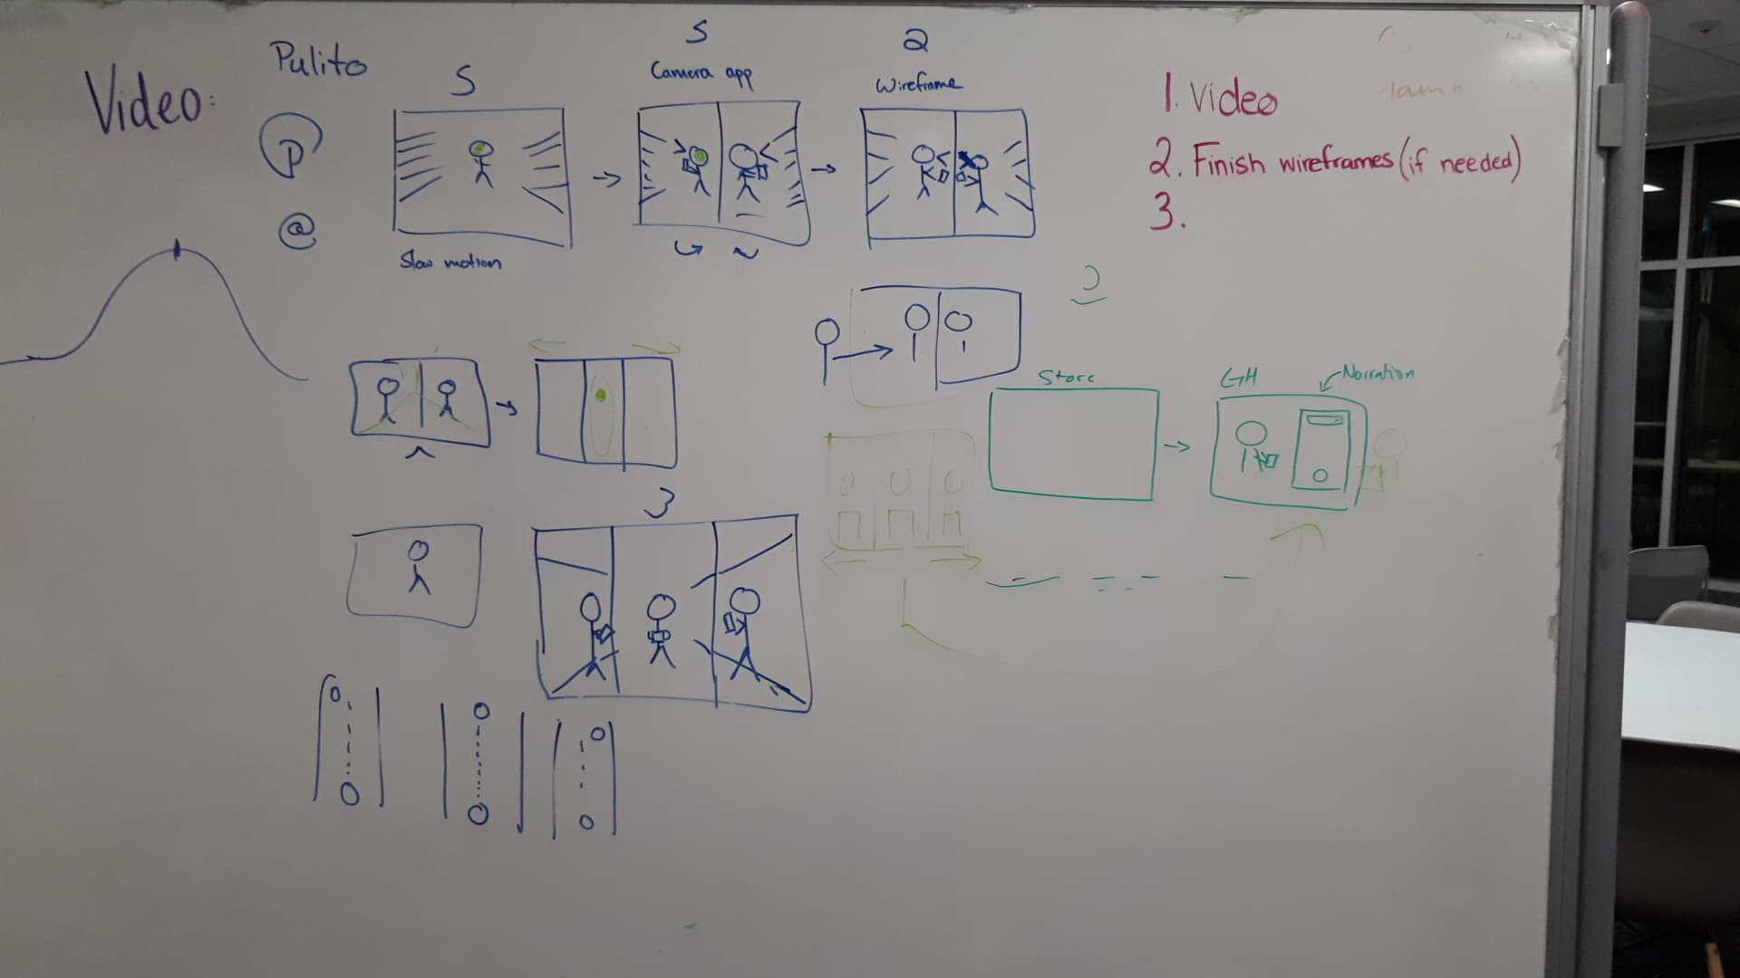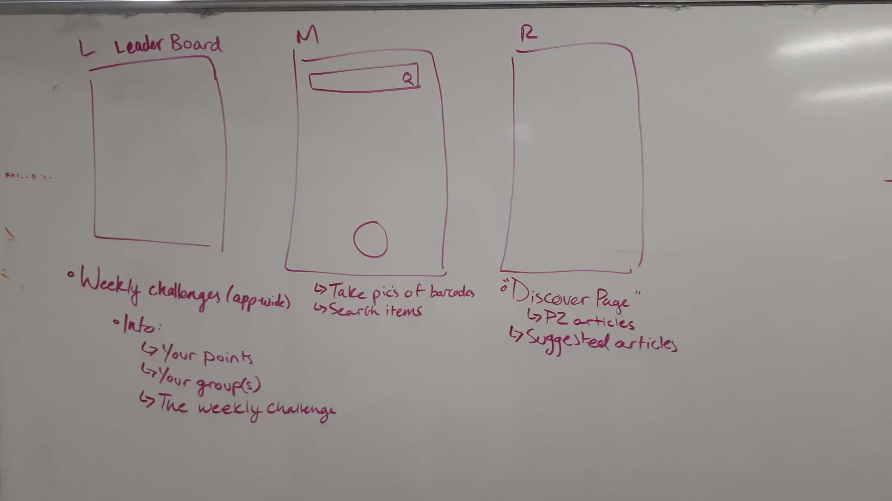 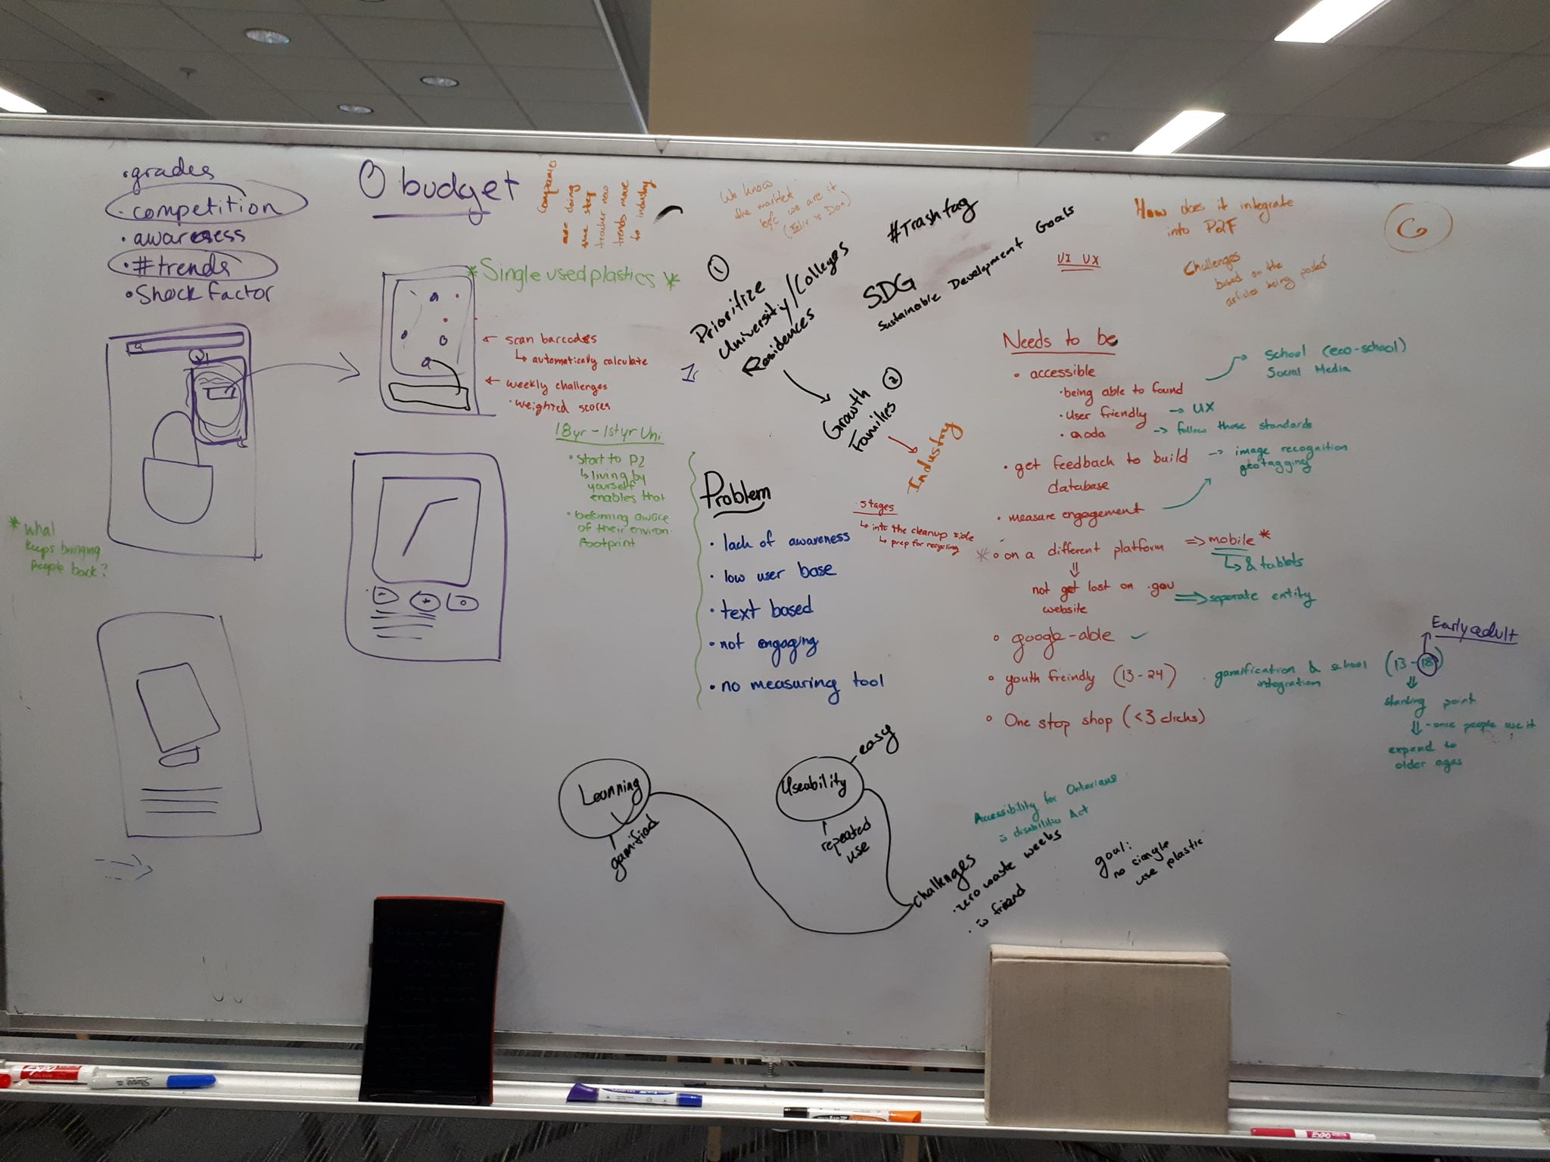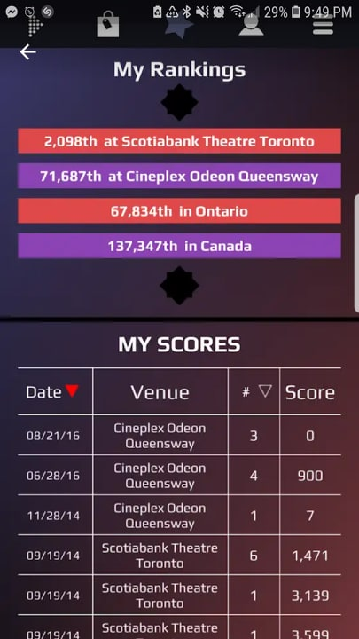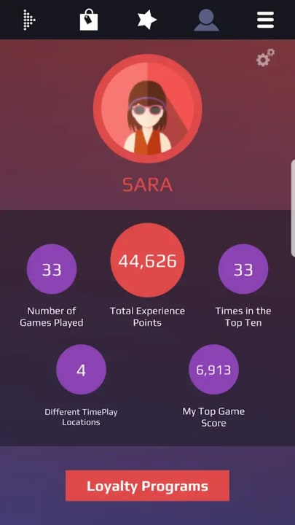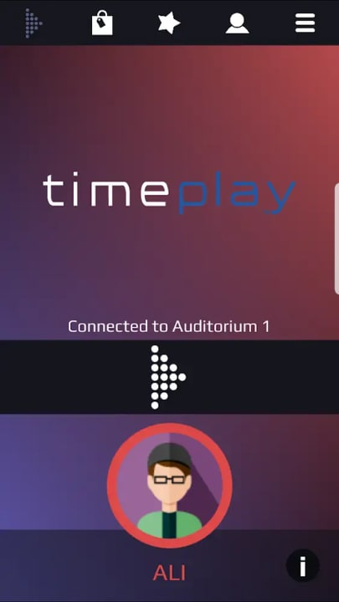

Stratford Blooms Re-Design

Outline of Case Studies 🡪 Inspo: <http://abdussalam.pk/project/tv-guide-app>

More Inspo: <https://www.jackiensabillon.com/>   
<https://www.rahpdesign.com/>  
<https://www.megantruong.com/>

Roles

* Single statement summarizing the UX Case
* Listed
  + My Role
  + Platforms
  + Year Project Was made

Problem

* Key Drivers
  + List and briefly explain what sparked your design
  + Inspirations
* Images of the UIs
* Current Solutions
  + Briefly list them

Research

Solution

* + Methods of Research
  + Data (if can be provided)
* Journey Mapping – explain journey of user
  + User profiles
  + Maps
  + Sketches
* View WIREFRAMES in Hi-Res
  + PDF form
  + Or however you’d like to show it
  + Ideas to action
  + Lo-fi
* Modular Design System – explain why you used such tools etc.
  + Color Scheme
  + Fonts
  + Tools
  + Assets
  + Individual images and text
* (Optional if doable) Motion graphic of Hi-fi (i.e scrolling through the app etc.)
  + Or just have an InVision prototype screen record
* User Onboarding
  + Hi-res of Hi-fis
  + Scroll through screens
  + SHOW. EACH. DETAIL
* Show the Hi-fi Artboards
* REFER TO OTHER PROJECTS

Results

PULITO

Outline of Case Studies 🡪 Inspo: <http://abdussalam.pk/project/tv-guide-app>

EDC links:

EDC Event Article:  
<https://uwaterloo.ca/stpauls/greenhouse/greenhouse-hosts-design-challenge-environment-canada>

P2 Resources   
<https://pollution-waste.canada.ca/pollution-prevention-resources/Home/Record/?RefNumber=3448&fbclid=IwAR34GozyHmYdLe973zrdN3eNjoq81YwW0pdROZ1X1y1FVo9yHUuK_G-SND0>   
  
Google Slides  
<https://docs.google.com/presentation/d/101LazE1cJ2pMgXLXUlZ7Ajlwn9k1XAwTO-svqIP0E40/edit?fbclid=IwAR2MGE19gh6KkIHu3nmhq4F_vPZIRizr1K37lYBuRWrWW5OPsYx9zNgriG8#slide=id.p>   
  
Figma 🡪 lofi / hifi mock ups and inspo  
<https://www.figma.com/file/RlkHfR79ldVaMgVaAlKVJV26/EDC---Pulito?node-id=0%3A1>   
<https://www.figma.com/file/RlkHfR79ldVaMgVaAlKVJV26/EDC---Pulito>   
  
Figma 🡪 Prototype Mode  
<https://www.figma.com/proto/RlkHfR79ldVaMgVaAlKVJV26/EDC---Pulito?node-id=23%3A1&scaling=scale-down&fbclid=IwAR0YI01vXSoK0mNMuMyHG08zUZ2r8ZjhQ0EA_Onu0ugDbWI0OE2eqyjQaGg>   
  
Figma 🡪 Prototype Mode (Cart)  
<https://www.figma.com/proto/RlkHfR79ldVaMgVaAlKVJV26/EDC---Pulito?node-id=2%3A5&scaling=scale-down&fbclid=IwAR3NwFMpmcTb9j5D3pnVVVl7HTobCYfxlf91Ig4FM60WoqFebLoFM58bhpo>   
  
Article – One Ingredient Away  
<http://www.oneingredientmom.com/blog/2015/12/23/what-is-a-one-ingredient-mom-anyway?fbclid=IwAR0HZD7bq2YUXFIsZ0jvH0PTXTAi6znodF1xVfGdiIcn0qe5FXio9yOABpc>   
  
Google Drive  
<https://drive.google.com/drive/folders/1w8lwnjmshfN-ycmJwmubUPp9qpNFCYYZ?usp=sharing>

* Listed
  + My Role – UI / UX designers, ideation process, logo design maker
  + Platforms – app design, InVision, Figma, After Effects, Illustrator
  + Year Project Was made – 2019
  + Environmental Design Challenge 12Hour Hackathon Event

**synopsis**

* + **background:**
    - On March 15th the University of Waterloo’s St. Paul’s College hosted an Environmental Design Challenge. This event was sponsored by Environmental and Climate Change Canada.
    - ECCC developed their Pollution Prevention (P2) Resource Finder; it is described as “Canada's one-stop database of online pollution prevention resources.”
  + **what is the P2 finder?** 
    - The P2 finder enables individuals to find practical pollution prevention tips, tools, and guidance to make more sustainable choices in their everyday life. It includes articles and small “hacks” that eliminate waste and encourages sustainability.
    - The P2 finder can be accessed on the Government of Canada website, but it can still be inaccessible due to the update of our technologies and ways of accessing information.
  + **the challenge?**
    - How might we create a mobile digital solution to empower youth and those that interact with youth engage with pollution prevention information?

**challenges**

* + **our findings**
    - Upon navigating through the P2 finder on the government website, we’ve encountered some paint points that is key to address in our final solution:
    - **lack of Awareness** 
      * Even we had no idea there are pollution prevention practices that are not preventing pollution at all
      * We had no idea that the P2 finder exists
      * We didn’t even know where some of our everyday plastics and items that we use go to when we dispose them (are they recycle? Garbage? Etc.)
    - **P2 targets older audiences**
      * Information presented is very text-heavy and hard to read
    - **P2 is not engaging** 
      * It only provides long read of articles
      * Lots and lots of text but not the best method for people to use if they’d want learn information and if we want information to stick with the users
    - **P2 has no measurement tool** 
      * There’s no measuring tool
      * Users don’t know if they are making any difference with their pollution prevention practices
      * There’s no data available to see progress or use (even simple facts by turning to a more PPP’s

**key drivers**

* + **List and briefly explain what sparked your design**
  + **determining our market**
    - As the challenge outlined the importance of “youth participation” we thought that the “youth” is a large and vague market. We decided to focus on a specific kind of youth where they are in the middle of learning to live an independent life, turning their focus not only their education but their well-being – university students residing on campus (residents).
    - **reasoning** 
      * As university students ourselves, we are constantly learning how to become independent and continuously try to find ‘hacks’ to make our everyday lives easier. If we targeted individuals who are always curious and in a time of their lives where they are figuring things out, we can help them develop good habits especially in the realm of pollution prevention choices.
  + **top 5 things that our market values** 
    - Grades
    - Competition
    - Awareness
    - #trends
    - Shock factor
  + **must haves**
    - **accessibility / ease of access**
      * easy to navigate through, easy to understand, easy to find
      * AODA approved (accessibility approved and follows the standards)
    - **designed for the student market**
      * our solution and design should be designed for the market, taking into consideration the technologies they use and are familiar with, also their method of learning or taking in information
    - **ease of understanding**
      * information presented should be easily understood upon access. There should be no indirect or underlying information, everything should be direct and straight-to-the-point.
    - **increasing P2’s digital presence**
      * the more people are aware of the P2 finder and its resources, the more people would rely on it for pollution preventions
    - **feedback built in database** 
      * from Image recognition, Geo tagging to simply providing data of the effect of the user’s participation – feedback is key as it also provides comfort with the users
    - **measures engagement** 
      * point system only adds on to the competition
    - **accessible on different platforms** 
      * Not get lost on the government website
      * Separate entity
    - **one-stop shop (less than 3 clicks from user)**
  + **inspirations**
    - Our inspiration included Pokémon Go and the Cineplex Game app called Time Play
    - Interacting in a group or collaborative activity with others, their surroundings as well as gamifying aspects of the P2 finder would highly complete our goal and check off our key drivers
* ~~Images of the UIs (lofi)~~

**solutions (list + summary)**

* + **integrate collaboration**
    - Weekly competition between users, has a team and collaboration aspect.
  + **point system (-/+ for specific actions and uses)**
    - Everyone likes a friendly competition, therefore adding a point system would only increase excitement and use of the P2 finder app
  + **target a small section of the ‘youth’**
    - It is easier to first target a small section of the youth that are established (in a facility, life in that specific point in time in their youth would have to make independent decisions and choices – this app then can guide them to make more pollution prevention choices)
    - Our targeted youth being university students / mostly in residences as it pertains to the school environment as well
  + **developing good habits among the users** 
    - These would enable users to accomplish good while learning gradually through repeated use due to ease of use and friendly competitions
  + **ease of accessibility is KEY**
    - The P2 finder now is very cluttered as it has abundance of information, it gives you many options and article that the most useful / reputable sources are lost in the variety of information – by making the P2 finder easier to read and navigate through (through our redesign) it would make it more appealing to users.

**research**

* + **Methods of Research**
  + **the market**
    - We understand the market as WE are the market, we used our personal experiences (as students) and compared what pollution prevention choices we’ve made and continuously make
    - We had Felix, our teammate and former don / student leader; share his experience living in a residence as a don and the influence he has, simply because he is a student lead
  + **going on the P2 website** 
    - We personally navigated through the P2 website and read the articles provided pollution prevention activities as well that we can possibly incorporate into the P2 app
  + **Data (if can be provided)**
    - **Include our whiteboard and ideation**
* **journey mapping** 
  + **Pulito.**
    - Pulito encourages building a community of good doers of the environment
  + **what is it?** 
    - This game-like, competitive app will have friends and family go head to head in using less pollutant-based products
    - This is a mobile app holds weekly competition among groups of friends to see who used the least amount of plastic / pollutant-based products based on groceries bought
  + **how does it work?** 
    - Using your cell-phone camera it will scan via barcode (or searched manually) and identify products and its information to determine its type and scale of pollutant
    - Each session is followed by articles from P2Finder’s database -- learning more about the products in your cart -- to not only educate the user of the environmental impacts but as well as compete in a game of knowledge!
    - The lower the amount of pollutant-based products bought the better!
    - Friends can also check your materials if you’re cheating by photo tagging
    - Easy as taking a selfie -- but with your groceries!
  + **how does it integrate the P2 finder?**
    - There is an increase of points if the user reads a P2Finder article presented
    - They get to share their achievements and learn their P2 ways of living through and easy weekly task -- buying groceries.
    - The game of knowledge: post-session quiz games between your friends and your team (and other app users) would make the app even more fun!
    - They’re able to track their consumption and use of pollutants -- being knowledgeable of their use and impacts especially with the help of P2 articles alike
  + **why will it work?** 
    - Targeting first year students while they are transitioning to their independent student life
    - Developing good habits while learning gradually through repeated use accomplished by ease of use and friendly competition
  + **User profiles**
  + **Maps**
    - Profile 🡪 Leaderboard 🡪 weekly challenges (app wide) 🡪 personal points / groups / Weekly Challenges 🡪 Taking pictures of barcodes / search items 🡪 Discover Page: P2 Articles / Suggested Articles
  + **Sketches**
* View WIREFRAMES in Hi-Res
  + PDF form
  + Or however you’d like to show it
  + Ideas to action
  + Lo-fi
* Modular Design System – explain why you used such tools etc.
  + **Due to this challenge’s short period of time we ended up using the built-in colors and fonts provided by Google Slides** 
    - Helvetica
    - Lime Green etc.
  + Color Scheme
  + Fonts
  + Tools
  + Assets
  + Individual images and text
* (Optional if doable) Motion graphic of Hi-fi (i.e scrolling through the app etc.)
  + Or just have an InVision prototype screen record
* User Onboarding
  + Hi-res of Hi-fis
  + Scroll through screens
  + SHOW. EACH. DETAIL
* Show the Hi-fi Artboards
* REFER TO OTHER PROJECTS
* Takeaways
  + **takeaways**
    - The EDC challenge was a very fun experience overall; I’ve learned that we have many pollution preventions options to choose from that can help make a difference no matter how small they are. This design challenge helped me understand and realize the many resources we have available to us, it’s only a matter of its ease of accessibility and legibility. No matter how much information we’d like to include within our app or we will be including when integrating P2.
    - **communication**
      * A 12hour hackathon can go by fast, having all your team members on the same page is very important when executing a project. My team and I made sure everyone understood the challenge prior to dividing tasks, we all assisted in the ideation process and vocalized whenever the idea is unclear or if we are inconsistent with where our idea is going. I really appreciate how my team always gives me their feedback and input in the UI design to make sure that we are on track and that everyone understands the system of the app.
    - **design**
      * Two words: Design Systems! Sometimes being in the thick of the competition, you get lost in the challenge, designing whatever “looks good” rather than what works best for the user. When we began designing the app, I started to go haywire! From the navigation bar to what kind of button it should have or whether it should have an off shadow with the images – pointless design thinking because I was really focused on how it looked rather than its system. I ended up creating screens that were not needed and did not pertain to our idea, the UIs became inconsistent! We learned the importance of having a solid design system to follow so that we do not forget any screens or make unnecessary ones.
    - **next steps**
      * As we continuously create and innovate, we also continue to mindlessly make pollutive choices – we hope to integrate Pulito or something of a similar application and practice in our everyday lives soon. We hope to involve more stakeholders for research, testing and design phases as well as explore more design solutions to guarantee its use and reliability.
      * We hope to expand our market from University / College Residence to families (at home challenges, family-based) and then to an industry of some sort such as competition between restaurants etc.
    - **last comments:**
      * I had so much fun working with my team in this Environmental Design Challenge! I hope to hone my design skills and participate more in design challenges such as these!